*Add your company logo here*

**OUR UNITED WAY CAMPAIGN IS ONLINE!**

Look out for the

campaign email with

your personalized link

to learn how you can

take action against poverty!



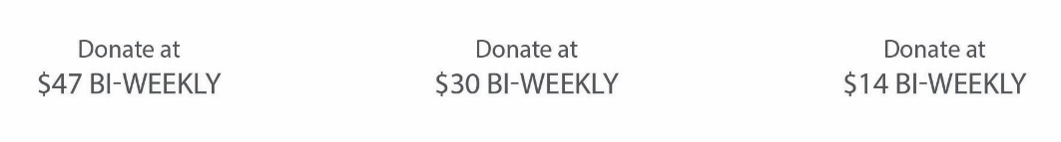

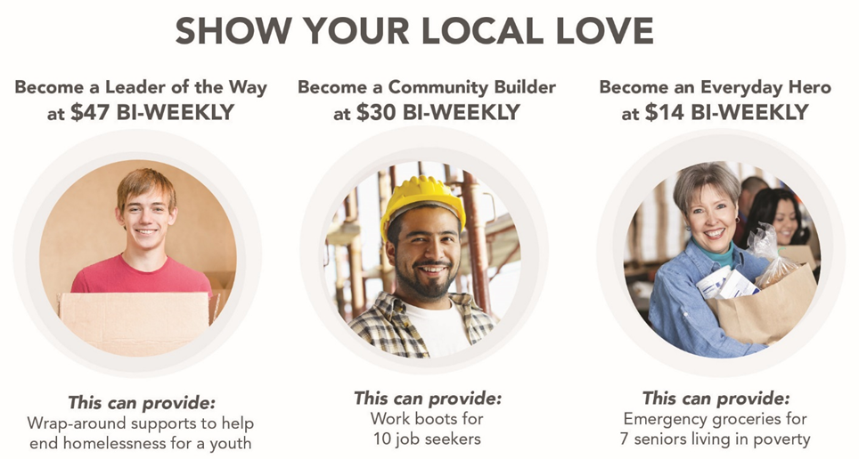

**Our campaign launches on:**

***Example: Monday, September 26***

**Key events and information:**

***Example: This year we are hoping to raise over $50,000 for our United Way Campaign!***

***Campaign Kickoff***

*Starts at lunch on September 26 in the lobby. A hot lunch will be waiting, don’t be late!*

***Early Bird Draw***

*Make your decision to donate by October 5 to qualify for our Early bird draw. Don’t be late!*

***Silent Auction & Pie Throwing***

*Will be at lunch on Friday, October 5 at noon. Contact Jane at jjohnson@company.com.*

***Campaign Wrap-up***

*Join us for a special surprise on October 12, in the lunchroom. You won’t want to miss it!*

***Campaign contact:***

**Example: Joan Smith, Campaign Chair jsmith@company.com**

**Joe Jones, Canvasser jjones@company.com**

**What Your Donation Supports**

**How your gift can make a lasting difference in our community.**