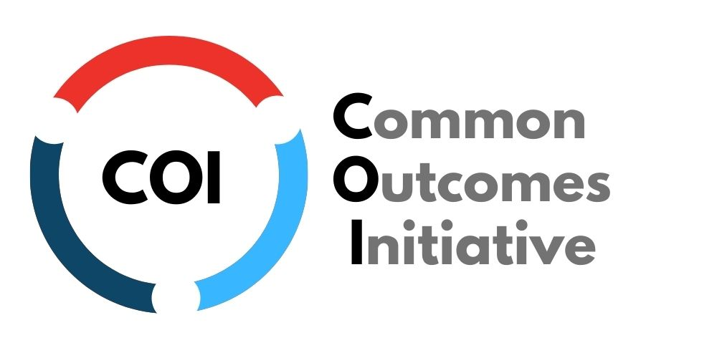

Common Outcomes Report (COR)
Work Book

Reporting Year
2022

Full User Guide is available on the Edmonton FCSS Website
OR
Full User Guide is available on the United Way Website

Common Outcomes Report
Please remember, you must complete one Common Outcomes Report for EACH PROGRAM/PARTNERSHIP you are funded through Edmonton Family and Community Support Services (Edmonton FCSS) and/or United Way of the Alberta Capital Region, (United Way).
You or someone in your organization, should have received ONE report link for each program.
The COR User Guide and instructional videos (accessible here) are available to walk you through using, saving and submitting this report. This is a workbook of the questions in the report so you can prepare outside of the online document. Following completion of this report, the report will be emailed to the COR Report Recipient Contact, the Program Contact, and your funding contact. As a reminder, once you have submitted this report you are unable to make any changes.
Should you have any questions about completing the Common Outcomes Report, please reach out to your funding contact.
As a reminder, the reports are due January 31, 2023.
Outline of the Report
This page in the online form outlines the different sections of the report that will be relevant for you.

Section 1: Overview
a) Agency and Program Information (Autofilled)
b) COR Report Contact Info (Autofilled/confirm/adjust)
c) Program Contact Info (Autofilled/confirm/adjust)
d) Program Description (Autofilled/confirm/adjust)
e) 211 Update
Section 2: Program Inputs
a) Funding Sources (Autofilled/identify other sources of revenue)
b) Program Supports (FTE/Students/Volunteers)
If applicable: Edmonton FCSS Questions
a) FCSS Partnership Information for Partnership/Collaboration Funding Only (Partnership Summary)
b) FCSS Information and Referral for Information and Referral Programs Only (Referrals/Interactions/Social Media)
If applicable: United Way Questions
a) Fundraising question
b) Additional program information
c) Outputs
Section 3: Unique Participants
a) Unique Participants
b) Indigenous Participants
c) Racialized Individuals
d) Newcomer Participants
e) Participants by Gender Identity
f) Participants by Geographic Community (UWAY only)
Section 4: Outcomes & Indicators [this section will look different depending on who you are funded by]
a) Report on two (2) mandatory Edmonton FCSS outcomes/indicators (will auto-populate)
b) Report on one (1) mandatory United Way outcome/indicator (will auto-populate)
Section 5: Summary
a) Success Stories
b) Reflection Questions

Section 1a: Agency Overview
This information will be auto-populated based on the data provided in last year’s COR report. If you believe any of it is incorrect, please contact your funding contact.
Agency Name: This will now be auto-populated.
Program/Partnership Name: This will now be auto-populated.
Edmonton FCSS Liaison (if applicable): This will now be auto-populated.
United Way Manager(if applicable): This will now be auto-populated.
Section 1b: Common Outcomes Report Recipient
This is the person who fills out the common outcomes report. It will be auto-populated based on the data provided in last year’s COR report.
COR Outcomes Report recipient name: This will now be auto-populated.
COR Outcomes Report recipient email: This will now be auto-populated.
Is the contact information above accurate? Yes or No
If no, please correct:
COR Outcomes Report recipient name: ___________________________
COR Outcomes Report recipient email: ___________________________
Section 1c: Program Contact Information
This is the person who is the main contact for the program. It will be auto-populated based on the data provided in last year’s COR report.
Program/Partnership Contact Name: This will now be auto-populated.
Program/Partnership Email: This will now be auto-populated.
Program/Partnership Phone: This will now be auto-populated.
Is the contact information above accurate? Yes or No
If no, please correct:
Program/Partnership Contact Name: ___________________________
Program/Partnership Email: ___________________________
Program/Partnership Phone: ___________________________
Section 1d: Program Description
Program/Partnership Description: The description from last year’s COR report will be auto-populated. If the information is incorrect or requires an update, you can indicate as such and update the program name or description.
Is the program/partnership information above accurate? Yes or No
If no, please correct:
Adjusted Program/Partnership Name: ___________________________
Adjusted Program/Partnership Description Please note, this description is limited to 1-3 sentences (500 characters) and is used publicly. _____________________________________________________________________________________________________________________________________________________________________________________________________________________________________________________________________
Section 1e: 211 Update
211 Alberta connects Albertans to a full range of community, government, social and health services. It’s free, confidential and available 24/7 in over 170 languages. To reach 211, dial 2-1-1, text INFO to 211 or visit www.ab.211.ca for live chat and online search.
211 is currently the only service in Alberta accredited by the Alliance of Information and Referral Systems (AIRS), demonstrating 211’s excellence in service delivery, resource database stewardship, cooperative relationships, disaster preparedness and organizational effectiveness.
Is your agency’s listing in the 211 database accurate and up-to-date?
Visit your COR Invitation email for a link to your agency's listing
- Yes
- No
- Our agency is not listed in the 211 database

If not, have you contacted 211 to update or create this information? To update or create your listing, please contact the 211 Community Resource Department at database@ab.211.ca or 780-392-8722, or visit https://ab.211.ca/question/.
- Yes
- No

Section 2a: Funding Sources
Edmonton FCSS Core Funding: This will be auto-populated if you are funded by Edm. FCSS
Edmonton FCSS Other: This will be auto-populated if you are funded by Edm. FCSS other funding.
Collaborative Funding: This will be auto-populated if you are funded by collaborative funding between Edm. FCSS and UWAY
United Way of the ACR Funding: This will be auto-populated if you are funded by UWAY
*If you feel your funding amounts are incorrect, please reach out to your funding contact.

Are the COR funders (UWAY or Edm FCSS) the program’s sole funder(s)? Yes or No
(Sole funders indicates that this program is entirely funded by one or more of the COR funders)
If not, what other sources of funding are used for THIS program/partnership?
- AGLC/Casinos Amount: ____________
- Canada Summer Jobs Amount: ____________
- Donations Amount: ____________
- Edmonton Community Foundation Amount: ____________
- Fundraising Amount: ____________
- In-Kind Amount: ____________
- Revenue from membership and/or fees Amount: ____________
    - Sponsorship (Corporate) Amount: ____________
- Other City of Edmonton Funding Amount: ____________
- Other Government of Alberta Funding Amount: ____________
- Other Government of Canada Funding Amount: ____________
- Other Foundation Funding Amount: ____________
- Other Nonprofit Organizations Amount: ____________
- Other Municipal Government Funding Amount: ____________
- Other Provincial FCSS funding Amount: ____________
- Other _______________________ Amount: ____________
This “other funding” data, helps us to provide a picture of where funds are coming from outside of the two funders and how they contribute to the programs/partnerships that report to the COR.
Please note, if you select a box, enter an amount and then unselect the box, the total funding still calculates it. Ensure any data removed (boxes unchecked), that any data entered is also deleted from the amount boxes.
Section 2b: Program Supports

FTE’s (Full time equivalent)
Total Number Service Delivery FTEs for this Program (funded by all sources):
Enter # of FTEs for THIS PROGRAM ____________
For programs receiving FCSS funding for Partnerships/Collaborations
Total Number of Service Delivery FTEs for this Partnership (funded by all sources):
Enter # of FTEs for THIS PROGRAM/Partnership ____________
(For example, staff that are paid for through the partnership funding or accounted for in the budget)
Enter # of FTES that are in-kind for this partnership ___________
(For example, staff that are attending the partnership table as part of their paid position elsewhere, i.e. none of the funding supports paying these partner participants)

Students & Volunteers
Does your program/partnership use:
- Students/Practicum Students
- Volunteers
- Both
- Not applicable (program does not use volunteers)
If your program/partnership uses students:
Number of student/practicum volunteers:
Enter # of student/practicum hours for THIS PROGRAM/partnership ___________________
Number of student/practicum hours:
Enter # of student/practicum hours for THIS PROGRAM/partnership _______________________
If your program/partnership uses volunteers:
Number of volunteers:
Enter # of volunteers for THIS PROGRAM/partnership ___________________
Number of volunteer hours:
Enter # of volunteer hours for THIS PROGRAM/partnership ___________________
For each of the numerical questions in Section 2b, if your response is significantly different (25% more or less) from your response last year, you will be asked to confirm that the value you inputted was intended. This is simply a measure to help reduce error and keep our data clean.

Section 2c: FCSS Specific Questions (Only for those funded by Edmonton FCSS)

Partnerships & Initiatives
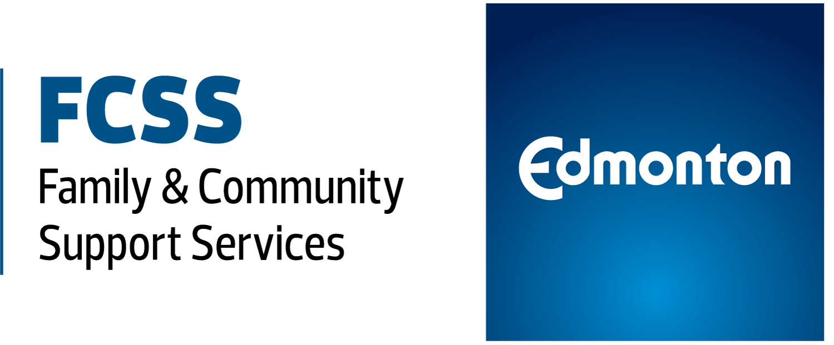
Only partnerships/collaborations that are funded specifically for working together will complete this page. All other funded programs no longer need to report on partnerships in the Common Outcomes Report.
Name of the Partnership: [auto populated]
Primary Focus of the Partnership (select one):
Categories for the Primary Focus: Anti-bullying, Community Mental Health Issues, Common Service Access, Community Capacity Building, Family Violence Prevention, Early Childhood Development, Homelessness, Inclusion and/or Diversity, Neighbourhood Building, Poverty Reduction, Safe Communities, Social Connection, Senior Wellness, Substance Abuse Prevention, Youth Engagement, Other
Number of partners involved: _____________
List of Partners:
_____________________________________________________________________________________________________________________________________________________________________________________________________________________________________________________________________
What were the main accomplishments of the partnership/collaboration this year?
_____________________________________________________________________________________________________________________________________________________________________________________________________________________________________________________________________

Please describe how this partnership (from your program’s perspective) is contributing to the identified focus.
_____________________________________________________________________________________________________________________________________________________________________________________________________________________________________________________________________

Information & Referral
FCSS Information & Referral Only: These questions ONLY show up if you are funded by EDMONTON FCSS and report in the Information & Referral Program Area.
If you do not collect this data, you do not have to report it. If you do collect some or all of this data, please report as much as you can and select not applicable if you do not collect data in a specific category.
Do you collect information and referral information?
- Yes
- No
If yes, please complete as much of the following information as possible:
Please select the types of information/referral requests you receive via:
- Phone Calls ___________
- Emails ___________
- Walk-ins ___________
- Not applicable ___________
To the best of your ability, please provide any of the information sharing that occurred through the number of:
- Newsletters sent out ___________
- Website hits ___________
- Participants at Information Fair(s)/Evening(s)/Session(s) ___________
- Not applicable ___________
To the best of your ability, please provide any social media interactions you had using:
- Facebook Followers: ___________
- Twitter Followers: ___________
- Other Social Media: ___________
- Not applicable ___________
Section 2c: UWAY Specific Questions (Only for those funded by UNITED WAY)
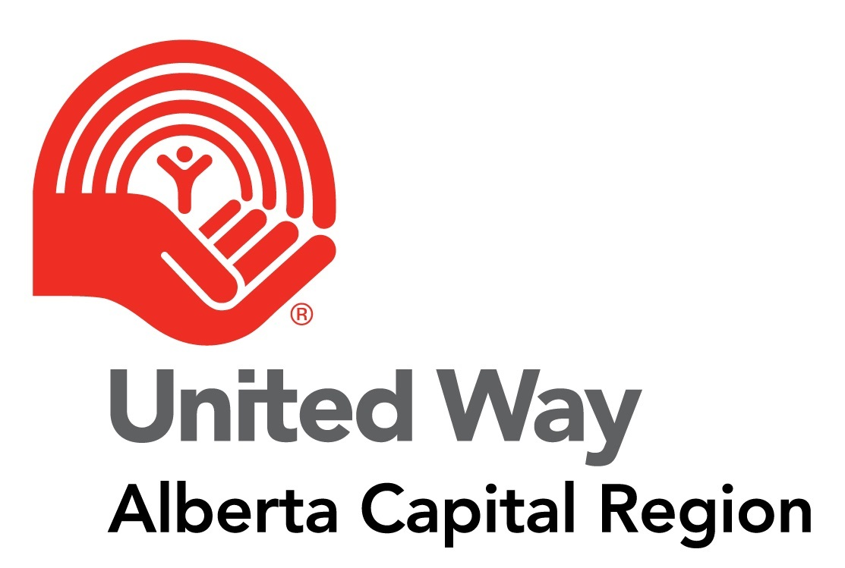

United Way fundraising efforts are more successful when we can articulate how our grants benefit the community and the agencies we support. We would like to know - Why does your organization value receiving funding from United Way? (For example, does it help reduce fundraising costs? Does receiving United Way funding help you apply for other funding?) (Optional, 500 characters)
________________________________________________________________________________________________________________________________________________________________________________________________________________________________________________________________________________________________
Provide an example of how the program contributed to Pathways out of Poverty. (500 characters)
________________________________________________________________________________________________________________________________________________________________________________________________________________________________________________________________________________________________
Have there been any changes to program activities, scope or demographics from what was listed on Schedule B of your program funding agreement? Yes or No
If yes, describe changes: ________________________________________________________________________________________________________________________________________________________________________________________________________________________________________________________________________________________________
Is there and/or will there be a program surplus or deficit for the most recent fiscal year?
- Yes, there is a program surplus
- Yes, there is a program deficit
- No, there is no program surplus or deficit
If you are reporting a surplus or deficit for the most recent fiscal year, please complete the following questions:
_______________ dollar amount of surplus or deficit dollars
What are the agency/program plans to address the surplus or deficit?
________________________________________________________________________________________________________________________________________________________________________________________________________________________________________________________________________________________________

Please report on a minimum of one output.
- Educational Supports
# of contact sessions: ___________________
# of supported referrals: ___________________
# of devices (computers & personal devices): ___________________
# of other (please specify): ___________________
- Parenting/Caregiver Supports
# of contact sessions: ___________________
# of caregiver workshops/sessions: ___________________
# of caregiver/child activity kits: ___________________
# of other (please specify): ___________________
- Financial Empowerment - Coaching
# of information/financial counselling sessions: ___________________
# of referrals: ___________________
# of other (please specify): ___________________
- Financial Empowerment - Education & Literacy
# of financial education/literacy sessions: ___________________
# of other (please specify): ___________________
- Financial Empowerment - Tax Preparation
# of tax returns prepared and submitted: ___________________
# of other (please specify): ___________________
- Employment Services
# of employment training/workshops: ___________________
# of resume/interview supports offered: ___________________
# of other (please specify): ___________________
- Basic Needs - Food Security
# of meals: ___________________
# of food baskets/hampers: ___________________
# of other (please specify): ___________________
- Basic Needs - Housing
# of contact sessions: ___________________
# of nights of shelter provided: ___________________
# of other (please specify): ___________________
- Basic Needs - Emergency Funds
# of emergency funds provided: ___________________
# of utility supports provided: ___________________
# of housing supports provided: ___________________
# of transportation trips (bus tickets, ride fare): ___________________
# of other (please specify): ___________________
- Reducing Social Isolation - Bringing supports to people who are isolated and who may not be able to participate in community-based group activities due to various barriers (seniors in residences with mobility issues, low-income single parents, people in domestic violence shelters) but the program comes to them through individualized supports/outreach/check ins.
# of contact sessions: ___________________
# of outreach visits: ___________________
# of transportation trips: ___________________
# of devices (computers & personal devices): ___________________
# of other (please specify): ___________________
- Mental Health & Wellness - Individual Counselling
# of counselling sessions: ___________________
# of supported referrals: ___________________
# of other (please specify): ___________________
- Mental Health & Wellness - Group Counselling
# of group sessions: ___________________
# of other (please specify): ___________________
- Mental Health & Wellness - Public Education
# of mental health workshops/presentations: ___________________
# of other (please specify): ___________________
- Information & Referral - Traditional Information & Referral phone or web interaction
# of calls/web inquiries: ___________________
# of Other (please specify): ___________________
- Information & Referral -Staff member(s) connect participants to resources (systems navigation, supported referral)
# of inquiries: ___________________
# of Other (please specify): ___________________
- Personal Safety
# of intakes: ___________________
# of nights of shelter provided: ___________________
# of safety plans: ___________________
# of Other (please specify): ___________________
- Social Inclusion - Increasing community connections and building strong relationships by bringing people together in groups. This could be through a culturally-based youth program, peer support group, recreation opportunities for families, etc. These programs reduce barriers for low income individuals and families so they can participate in society in a more fulsome way.
# of social activities: ___________________
# of outreach visits: ___________________
# of contact sessions (one on one): ___________________
# of learning devices (computers & personal devices): ___________________
# of Other (please specify): ___________________
- Strong Sector (Capacity Building) - Research
# of research projects: ___________________
# of partners engaged in research: ___________________
# of workshops/presentations: ___________________
# of other (please specify): ___________________
- Strong Sector (Capacity Building) - Evaluation
# of trainings/workshops completed: ___________________
# of evaluations completed: ___________________
# of partners engaged: ___________________
# of other (please specify): ___________________
- Strong Sector (Capacity Building) - Collaboration
# of partners engaged: ___________________
# of collaborations/networks facilitated: ___________________
# of collaborative meetings: ___________________
# of other (please specify): ___________________

Section 3a: Unique Participants by Age Category
Which age categories do these participants fall under:
- 0-5 # of participants 0-5: ___________________
- 6-12 # of participants 6-12: ___________________
- 13-17 # of participants 13-17: ___________________
- 18-24 # of participants 18-24: ___________________
- 25-64 # of participants 25-64: ___________________
- 65+ # of participants 65+: ___________________
- Age Unknown # of participants age unknown: ___________________
Total Unique Participants for this program/partnership _______________(this will auto-calculate in the form)
If the number of Unique Participants reported is significantly different from last year, you will be asked to provide context as to the reason for this difference. Your response to this question is for information purposes only and is to help us understand agency and community context. ________________________________________________________________________________________________ ________________________________________________________________________________________________

Page 3b: Participant Demographics for Self-Identified Indigenous Participants
Do you collect data on the number of Indigenous participants your program serves? Yes or No
If yes, please provide the breakdown of self-identified Indigenous participants by age. NOTE: only the age groups selected in section 3a will be visible on the online form.
Which age categories do these participants fall under:
- 0-5 # of participants 0-5: ___________________
- 6-12 # of participants 6-12: ___________________
- 13-17 # of participants 13-17: ___________________
- 18-24 # of participants 18-24: ___________________
- 25-64 # of participants 25-64: ___________________
- 65+ # of participants 65+: ___________________
- Age Unknown # of participants age unknown: ___________________

Page 3c: Participant Demographics for Self-Identified Non-Indigenous Persons of Colour / Racialized Individuals
Do you collect data on the number of Non-Indigenous Persons of Colour / Racialized participants your program serves? Yes or No
If yes, please provide the breakdown of self-identified Racialized participants by age. NOTE: only the age groups selected in section 3a will be visible on the online form.
Which age categories do these participants fall under:
- 0-5 # of participants 0-5: ___________________
- 6-12 # of participants 6-12: ___________________
- 13-17 # of participants 13-17: ___________________
- 18-24 # of participants 18-24: ___________________
- 25-64 # of participants 25-64: ___________________
- 65+ # of participants 65+: ___________________
- Age Unknown # of participants age unknown: ___________________

Page 3d: Unique Participants Self-Identified as a Newcomer
Do you collect data on the number of self-identified Newcomer participants served by your program? Yes or No
If yes, please provide the breakdown of self-identified Newcomer participants by age. NOTE: only the age groups selected in section 3a will be visible on the online form.
Which age categories do these participants fall under:
- 0-5 # of participants 0-5: ___________________
- 6-12 # of participants 6-12: ___________________
- 13-17 # of participants 13-17: ___________________
- 18-24 # of participants 18-24: ___________________
- 25-64 # of participants 25-64: ___________________
- 65+ # of participants 65+: ___________________
- Age Unknown # of participants age unknown: ___________________

Page 3e: Participant Data by Gender Identity
Does your agency/program collect gender identity information for program participants?
- Yes
- No
If yes, please provide the following:
How many participants identified as:
- Boy/Man/Male # of participants: ___________________
- Girl/Woman/Female # of participants: ___________________
- Gender Diverse # of participants: ___________________
- Gender identity not listed above # of participants: ___________________
- Prefer not to answer # of participants: ___________________
- Information not gathered # of participants: ___________________
If the “Gender identity not listed above” option is selected, you will be invited to provide the following optional information:
If available, please list any gender identities or language preferred by your participants to help us ensure future reports use language and categories inclusive to all people served.
NOTE: The total number of participants by gender identity, cannot exceed the total unique participants reported in section 3a. If you have the gender identity data for some but not all of your participants, please enter the remaining participants in the category “Information not gathered.”
For example, if you have 300 total unique participants, but only gender identity data for 200 of them, you would put 100 in the category of “Gender Identity Unknown” and assigned the other 200 accordingly.
Page 3f: UWAY Only: Participant Data by Community for Programs funded by United Way
Please select communities where you served participants last year:
- City of Edmonton # of participants: ___________________
- City of Fort Saskatchewan # of participants: ___________________
- City of Leduc & Leduc County # of participants: ___________________
- St. Albert & Sturgeon County # of participants: ___________________
- Stony Plain, Spruce Grove & Parkland County # of participants: ___________________
- Strathcona County # of participants: ___________________
- Out of Province # of participants: ___________________
- Unknown Communities # of participants: ___________________
- Other # of participants: ___________________
NOTE: The total number of participants by Geographic Location, cannot exceed the total unique participants reported in section 3a. If you have location for some but not all of your participants, please enter the remaining participants in the category “Unknown.”
For example, if you have 300 total unique participants, but only location data for 200 of them, you would put 100 in the category of “Unknown” and assigned the other 200 accordingly.
Section 4: Outcome Reporting
You will be asked to report on your assigned outcomes/indicators as per your funding letter/agreement(s). These outcomes/indicators will automatically populate in your report. For each indicator, you will be asked the following:
Please select when you collected the majority of the data: Choose One
- Pre
- Post
- Pre & Post
- During the Program
- During & Post
- Follow Up
- Pre, During & Post
Please select the tool most frequently used to collect the data: Choose One
- Administrative Statistics
- Direct Observation
- Group Discussion
- Interviews
- Review of charts or other documentation of participant progress
- Surveys/questionnaires
- Text Messages

If you used a survey tool, what question(s) did you use to gather data on this indicator? Open Ended
________________________________________________________________________________________

Number of Participants Tried to Collect Data From: __________________
Number of Participants Responded: __________________
Number of Participants That Experienced a Positive Change: __________________

Describe what positive change looks like for this outcome as seen through participants' own words, actions, or changes in their lives that further explain the numbers you have just reported? Open Ended
______________________________________________________________________________________________________________________________________________________________________________________________________________________________________________________________________

Section 5a: Success Story
Success Story
This is an opportunity for your program to share a success story regarding the impact your program or partnership has had on participants. The stories are read by the funders and used in the Common Outcomes Report roll up as well as other reporting documents to illustrate impact in a qualitative story form.
Please remember to remove the names of any staff or participants.
Enter your success story here: (Optional, maximum 3000 characters)
______________________________________________________________________________________________________________________________________________________________________________
______________________________________________________________________________________________________________________________________________________________________________
______________________________________________________________________________________________________________________________________________________________________________
______________________________________________________________________________________________________________________________________________________________________________
______________________________________________________________________________________________________________________________________________________________________________
______________________________________________________________________________________________________________________________________________________________________________
_______________________________________________________________________________________________________________________________________________________________________________
Success Story Consent
Permission to share your program’s success story:
By checking yes you are allowing the success story to be used by the two funding bodies for the Common Outcomes Report and other dissemination. We assume that this means that you have also received permission from the participant.
- Yes, we provide consent to share the success story.
- No, we choose to keep the success story private.

Section 5c: Reflection Questions (for all programs except for those receiving FCSS Partnership/Collaboration Funding)
Thinking about the program...
Tell us about some evaluation learnings you had in the last year. Discuss with your team and provide one or two examples. Optional
____________________________________________________________________________________________________________________________________________________________________________________________________________________________________________________________________________________________________________________________________________________________
Thinking about deeper, enduring impact for participants...
How are participant's lives being changed as a result of the program? Optional
______________________________________________________________________________________________________________________________________________________________________________
______________________________________________________________________________________________________________________________________________________________________________
Thinking about the barriers to success...
Please select barriers outside of core programming that you have had to address through additional program planning, activities and/or budget.
- Access to computers/technology
- Access to cultural teachings, language, learning
- Childcare
- Clothing
- Connection to community resources
- Counseling
- Employment supports (i.e. work wear, resumes etc)
- Food
- Housing Supports
- Literacy
- Transportation
- Mental Health & Addictions
- None of the Above

Please select barriers outside of core programming that you ARE NOT able to address.
- Access to computers/technology
- Access to cultural teachings, language, learning
- Childcare
- Clothing
- Connection to community resources
- Counseling
- Employment supports (i.e. work wear, resumes etc)
- Food
- Housing Supports
- Literacy
- Transportation
- Mental Health & Addictions
- None of the Above

Are there any other or new barriers program participants are facing?
- Yes
- No

Describe Barriers Open ended optional
_____________________________________________________________________________________________________________________________________________________________________________________________________________________________________________________________________

If so, how have you been trying to address them? Open ended optional
________________________________________________________________________________________
________________________________________________________________________________________

Section 5c: Reflection Questions (for programs receiving FCSS Partnerships/Collaborations Funding)
Thinking about the partnership/collaboration:
Tell us about some evaluation learnings you had in the last year. Discuss with your team and provide one or two examples.
______________________________________________________________________________________________________________________________________________________________________________
______________________________________________________________________________________________________________________________________________________________________________
Thinking about the impact on the community:
Please describe how the community impact was increased or decreased due to the work of the partnership/collaboration. If there were challenges, how did you overcome them?
______________________________________________________________________________________________________________________________________________________________________________
______________________________________________________________________________________________________________________________________________________________________________

Thinking about working together:
By working together, has the partnership/collaborations identified new ways to solve problems? Please explain.
______________________________________________________________________________________________________________________________________________________________________________
______________________________________________________________________________________________________________________________________________________________________________
How has working in partnership/collaboration increased your ability to more effectively meet the needs of our participants or the community (for example, freed up resources, gained access to new resources, gained expertise, increased efficiency, etc.)? If it hasn’t, why do you think that is?
______________________________________________________________________________________________________________________________________________________________________________
______________________________________________________________________________________________________________________________________________________________________________
Thinking about deeper, enduring impact for participants or systems...
How is the work of the stakeholders/partners changing the lives of participants or the system they are within?
______________________________________________________________________________________________________________________________________________________________________________
______________________________________________________________________________________________________________________________________________________________________________
Thinking about the barriers to success...
Please select barriers outside of core programming that you have had to address through additional program planning, activities and/or budget.
- Access to computers/technology
- Access to cultural teachings, language, learning
- Childcare
- Clothing
- Connection to community resources
- Counseling
- Employment supports (i.e. work wear, resumes etc)
- Food
- Housing Supports
- Literacy
- Transportation
- Mental Health & Addictions
- None of the Above

Please select barriers outside of core programming that you ARE NOT able to address.
- Access to computers/technology
- Access to cultural teachings, language, learning
- Childcare
- Clothing
- Connection to community resources
- Counseling
- Employment supports (i.e. work wear, resumes etc)
- Food
- Housing Supports
- Literacy
- Transportation
- Mental Health & Addictions
- None of the Above

Are there any other or new barriers program participants are facing?
- Yes
- No

Describe Barriers Open ended optional
_____________________________________________________________________________________________________________________________________________________________________________________________________________________________________________________________________

If so, how have you been trying to address them? Open ended optional
________________________________________________________________________________________
________________________________________________________________________________________
Section 5e: Supplementary Information (Optional)
Use the space below to provide additional information, context or clarifying notes.
______________________________________________________________________________________________________________________________________________________________________________
______________________________________________________________________________________________________________________________________________________________________________
If you have an additional research or evaluation report/publication you would like to ensure the funders receive, please link to it here. Please note, this is optional and only provided for agencies to showcase additional research, outcomes and evaluation work.
____________________________________________________________ (provide link)

COR Summary
Proof of COR Report submission will be emailed to the following people:
1. COR Report Recipient
2. Program Contact
3. Funder(s)

Please remember, all reports must be complete via
the ONLINE FORM.
The Common Outcomes Reports are due on JANUARY 31st, 2023.

